

**Ticket Concert Project**

By

1. Miss Kob Student ID 6504062610013 No.2

2. Miss Paphawarin Suchantabut Student ID 6504062610170 No.15

3. Miss Usanee Komas Student ID 6504062610331 No.28

4. Miss Sutthara Pornlerdsawangsuk Student ID 6504062620205 No.44

Adviser

Asst.prof.Khantharat Anekboon, Ph.D.

This project is a part of the System Analysis and Design course

King Mongkut’s University of Technology North Bangkok

1. System Request

System request – Concert ticket Project

**Project Sponsor**: Marketing

**Business Need**: Generally, in Thailand, there are relatively few websites for purchasing concert tickets. The most well-known platforms include Thaiticketmajor, Event Pop, and The concert. Each of these websites faces various issues such as frequent crashes, slow loading times, and instances where individuals buy a large number of tickets only to resell them at inflated prices. These issues have led to dissatisfaction among users. As a response to these challenges, we have initiated this project to address these problems.

**Business Requirement**: By using our website, customers will be able to do the following:

-Search for concert tickets

-Purchase concert tickets

-Check dates, times, venues, and prices of concerts

-Receive e-tickets to avoid additional printing costs for customers.

**Business Value** : Within 4 years, we believe that we will make a profit

-selling tickets 1,535,000 baht

-Fee 9,000 baht

-Sponsor 325,000 baht

**Tangible**: Increasing profit by 1.5 to 2.5 million per year, after four years of starting the business.

**Intangible**: -Customers are increasingly satisfied.

-The company's reputation is becoming more widely recognized.

-Bringing in more customers than before.

-Attracting a greater number of investors to invest in the company.

**Special issues or constraints**

Creating a website for purchasing concert tickets can encounter various challenges depending on the complexity and details of the project.

Here are some potential issues that might arise:

-The website might not sell well because there is a new competitor.

- Security and Privacy Concerns

Our website collects customers' personal information such as ID cards, passports, and credit card numbers. The storage of credit card and user personal data must adhere to security standards, such as using HTTPS and encrypting sensitive information, to prevent data breaches and potential hacking incidents. This is crucial for customer security, peace of mind, and our company's credibility.

- Payment System

A secure and convenient online payment system is vital for purchasing concert tickets. Using trusted payment service providers like PayPal, True Money, or other reputable payment processors is essential. The payment system must be properly implemented and thoroughly tested to prevent errors.

- User Experience

The design of our website and user experience significantly impact user satisfaction and usability. We invest heavily in creating a website layout and experience that users will find pleasing and enjoyable to use.

- Cross-Device Compatibility

The website should be designed to be usable on various devices, including computers, tablets, and mobile phones. It should have a responsive design that adapts to different screen sizes and device types, ensuring a consistently pleasant experience for users.

- Technical Challenges

Compatibility with different web browsers, loading speed, payment problems, and data overlap issues may arise. For instance, duplicate ticket purchases, simultaneous payment processing delays, and database connectivity issues could occur.

- Maintenance and Updates

Regular maintenance and updates are necessary to ensure the website functions correctly over time. Neglecting maintenance can lead to various problems and disruptions in functionality.

- Integration with Other System

The website needs to work seamlessly with other systems, such as concert management systems, payment processing systems, or other related platforms. We might encounter challenges in data integration and system interoperability.

By addressing these potential issues and implementing effective solutions, we can create a successful and reliable concert ticket purchasing website that provides a secure, convenient, and enjoyable experience for users.

Top of Form

Bottom of Form

2. Feasibility

**Technical Feasibility**

-The total number of team members is 4 people. The total working period is about 4 months. The probability of completing this project is 80%.

**Economic Feasibility**

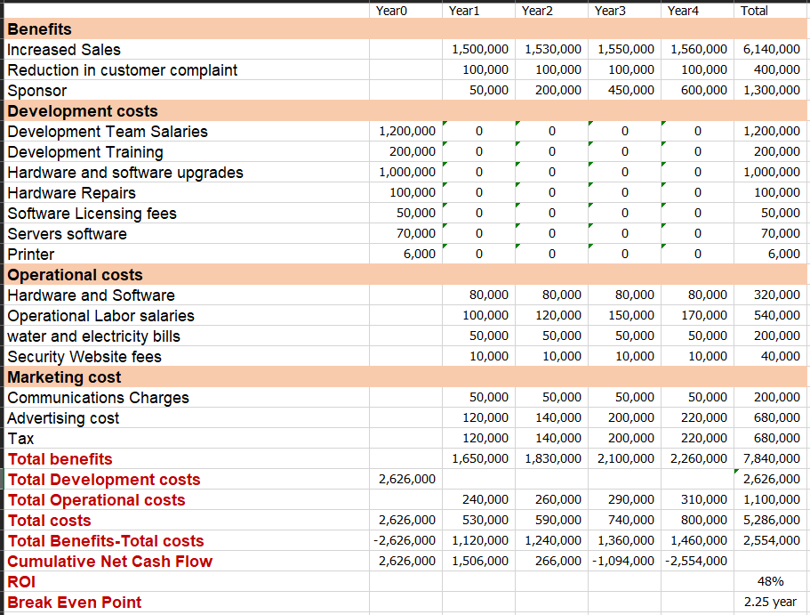

**Organizational Feasibility**

The success of any project heavily depends on effective management and leadership. The client company should have a dedicated team capable of overseeing the development, implementation, and ongoing management of the ticket reservation system and maintaining a ticket reservation system requires financial resources, human resources, and time. The client company must be prepared to allocate the necessary budget, personnel, and time to develop, launch, and maintain the system effectively. This includes hiring or training technical staff, as well as allocating funds for software development, infrastructure, and marketing.

3.Project Schedule

The agile approach to SDLC (Software Development Life Cycle) has many advantages that can help the project work efficiently and respond to the changing needs of customers and the business environment.

**Advantages of using SDLC Agile**

- Flexibility to update requirements Because there may be demands that change all the time, such as increasing or decreasing concert times.

- Responding to the needs of users can listen to their needs. Which makes it possible to get the right work that meets the needs of the user.

- The website for concert tickets may involve intricate operations, and employing Agile methodologies enables the capability to continuously adapt to changes.

- Tested and rated for high and stable performance all the time.

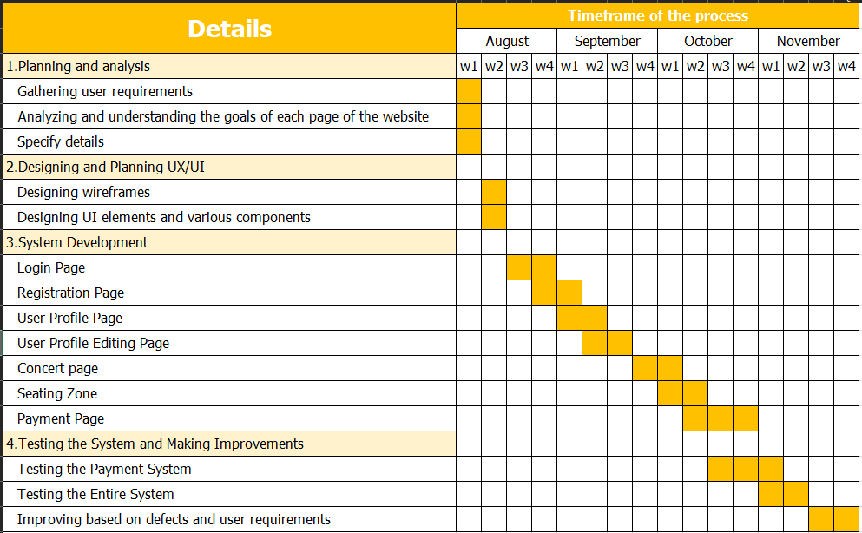

4. Functional Requirement

- Can search for desired concerts.

- Edit your account anytime.

- View dates, times, venues, prices, and other special conditions.

- Check seat availability.

- Convenient e-ticket for users.

- Multiple and convenient payment options.

5. Non-functional Requirement

**Availability**

- It is a system that works 24 hours a day.

- When it comes to the payment process, the system will be more stable. no downtime Because it is a very important step for the user.

**Usability**

- The screen is designed to be easy to use. due to the use of contrasting colors Easy-to-read fonts for easy visibility by users and accompanying icons for easy understanding.

- There are languages ​​to support both Thai and English which are international languages.

**Security**

- The system is safe in the process of entering the password because there is protection from seeing the password.

- There is an I'm not a robot function to prevent bots from entering the system.

6.Requirement

**Interview with individuals**

Interviews with people who have experience with pressing concert tickets, online interviews

**first interviewee**

**Location**

Instagram direct message

**Objectives**

- User concert ticket press experience

- Problems while holding concert tickets

- User preferences regarding the concert.

- Payment process

**Problem**

- The website crashed .

- There is an issue in the payment process, which is that payment cannot be made.

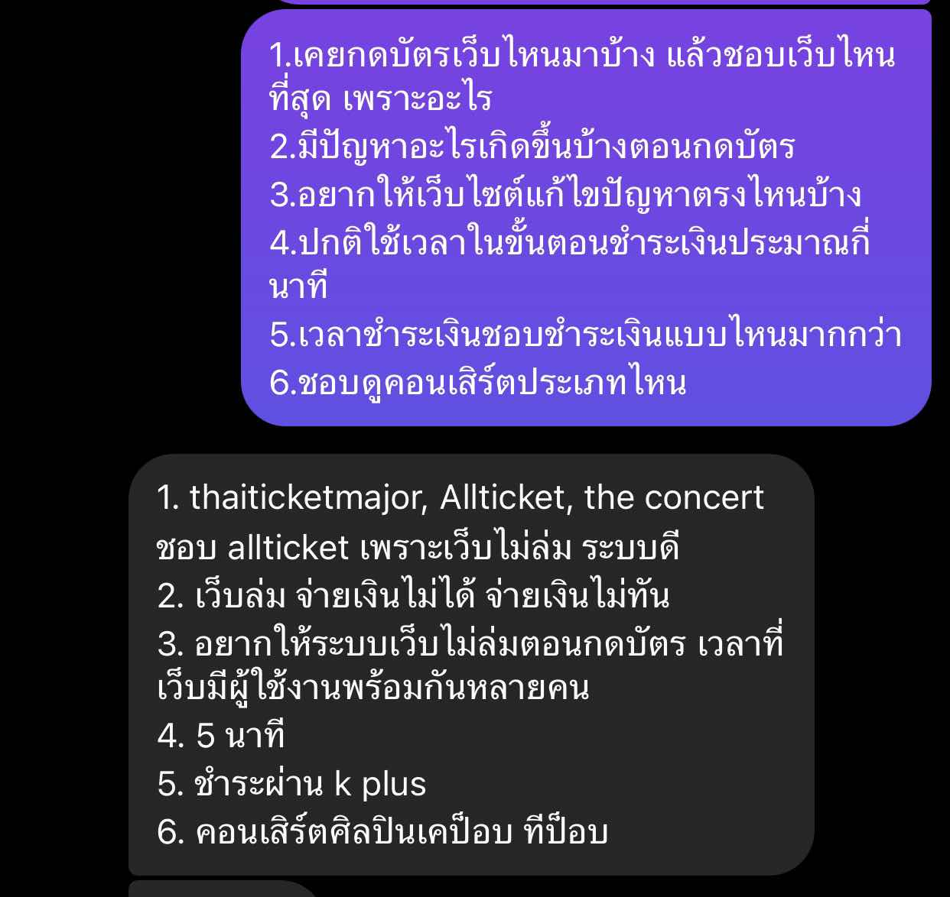

**second interviewee**

**Location**

Instagram direct message

**Objectives**

- User concert ticket press experience

- Problems while holding concert tickets

- Payment process

**Problem**

- Stuck webpage.

- Wasting time due to frequent website crashes.

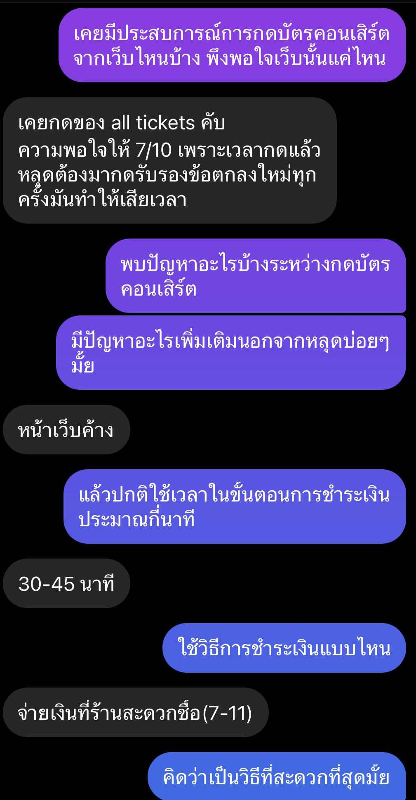

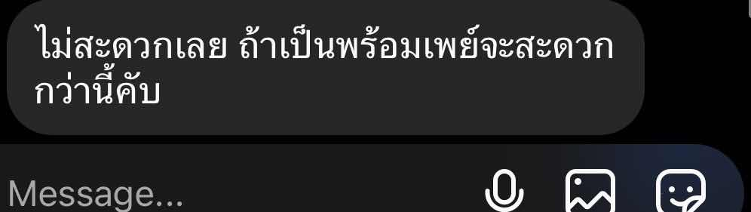

**third interviewee**

**Location**

Instagram direct message

**Objectives**

- User concert ticket press experience

- Problems while holding concert tickets

- Payment process

**Problem**

- The website crashed.

- seat not updated.

- Wrong date and time information.

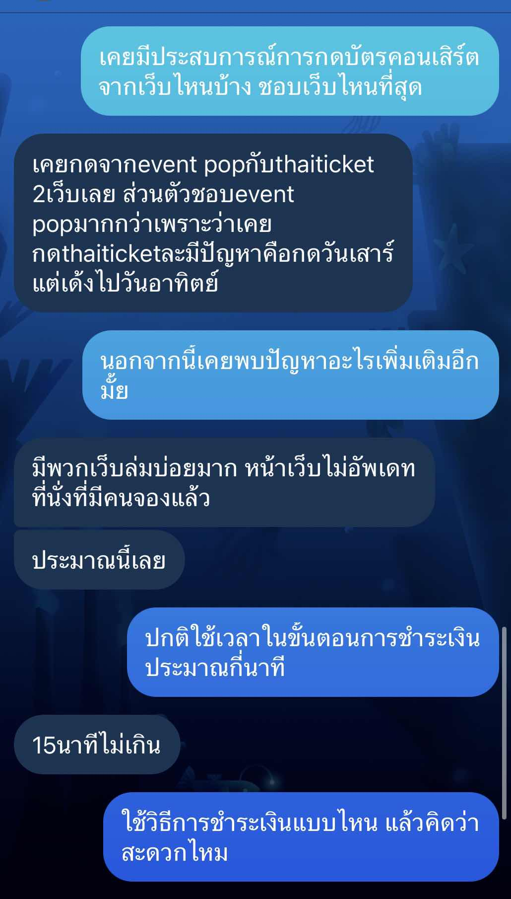

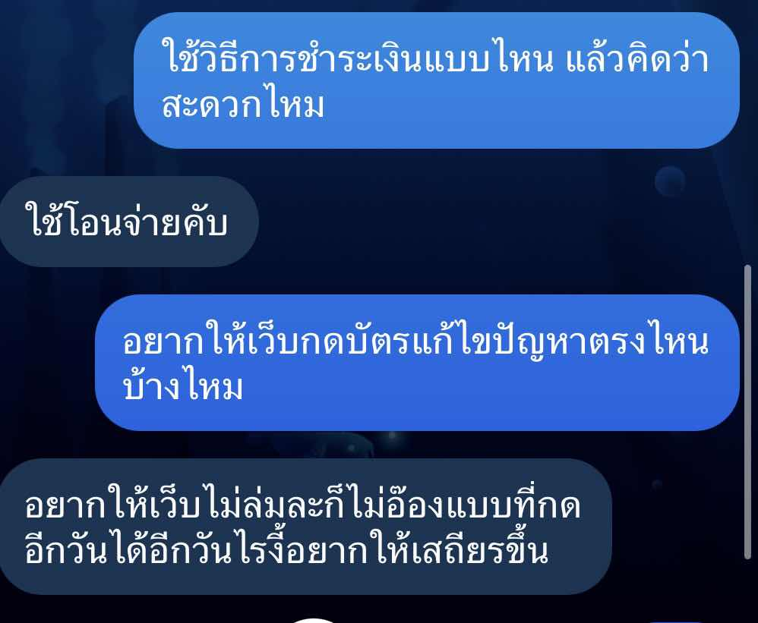

**fourth interviewee**

**Location**

Instagram direct message

**Objectives**

- Problems while holding concert tickets

Problem

- The website crashed

- Slow seat updates, not real time

- It's hard to pay. If you slip off the pay page, you have to start all over again

- require a person to press not too many concert tickets

- Some websites are also open to foreigners to press concert tickets, making it more competitive

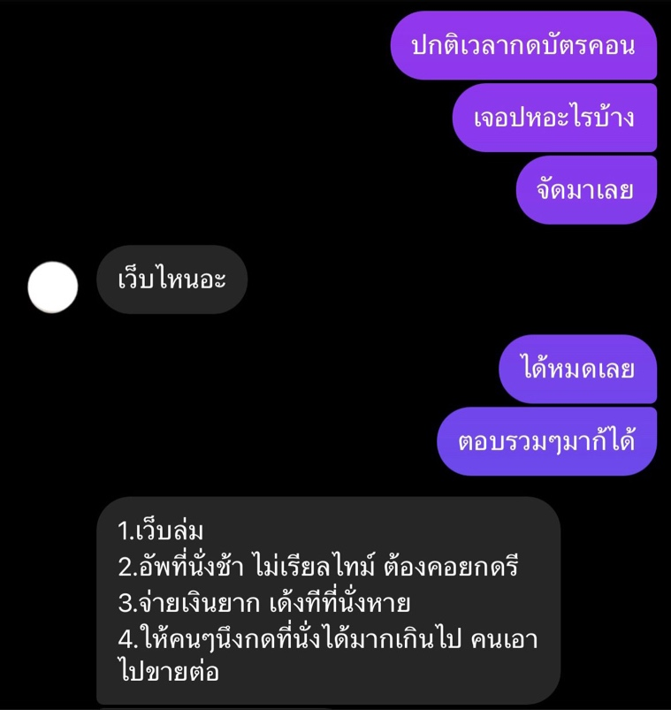

**Summarize the interview results**

The most common issues encountered during ticket booking for the concert are website crashes due to a high number of simultaneous users, incorrect data, and an average payment time of around 15 minutes. From this interview, it is clear that we should address the website stability issues, ensure accurate data, and adjust the payment process to be more user-friendly and suitable for general users.

Use case diagram



Use case description

sign up

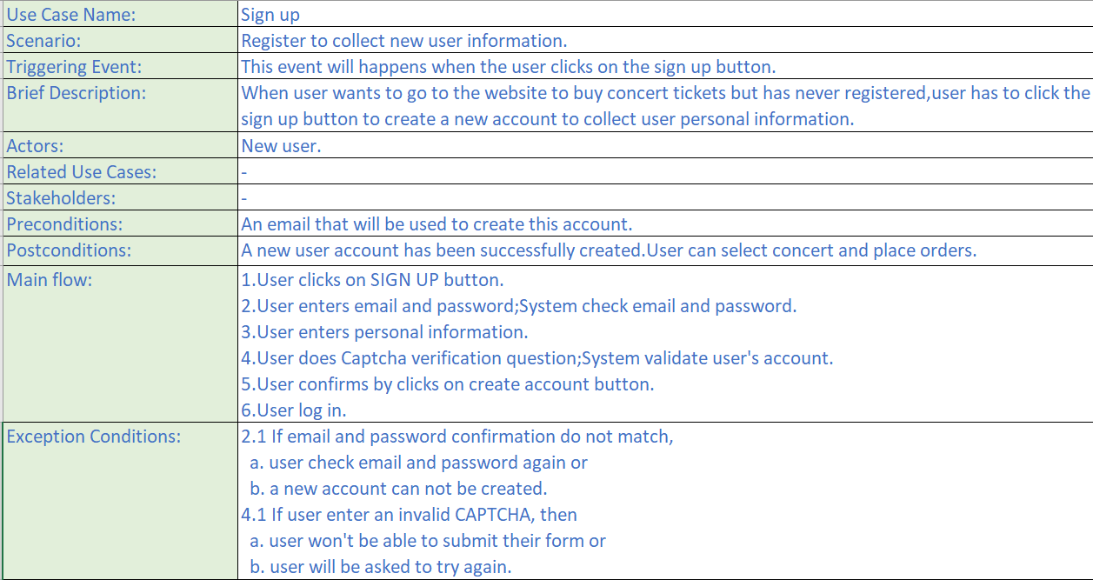

login

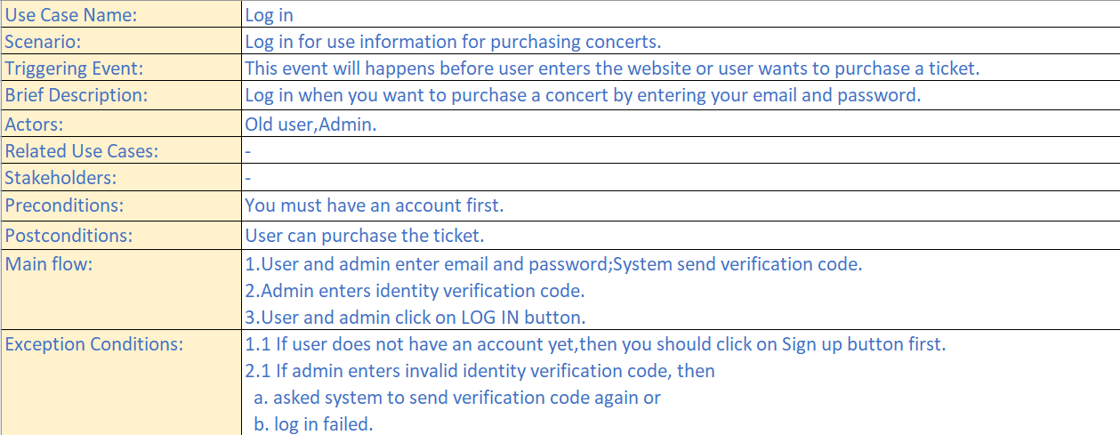

buy ticket

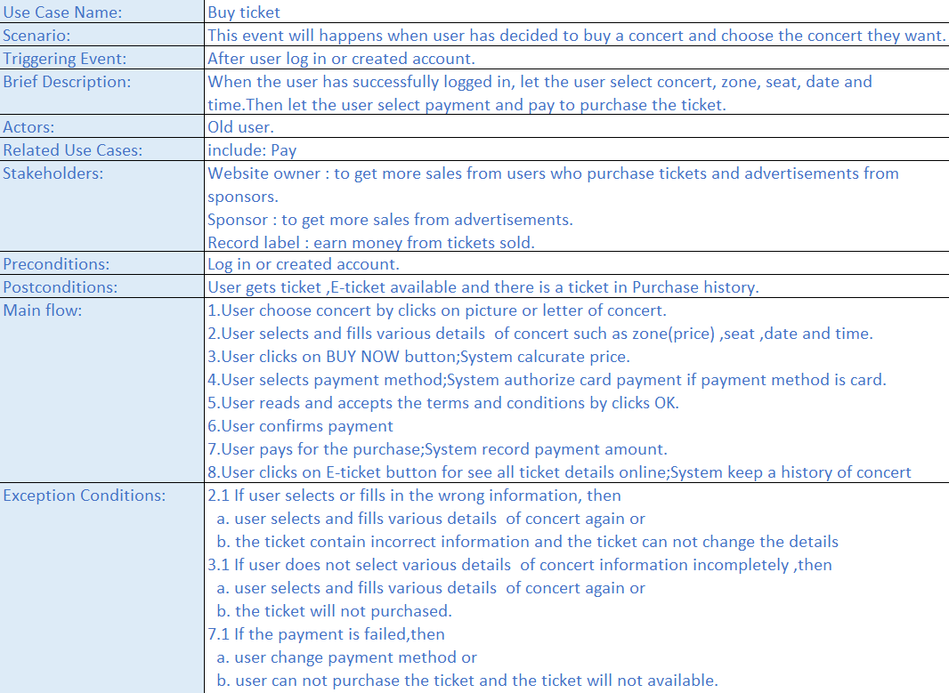

manage concert data

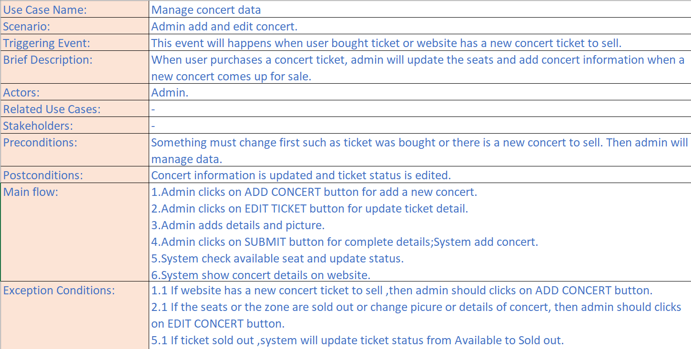

Context diagram

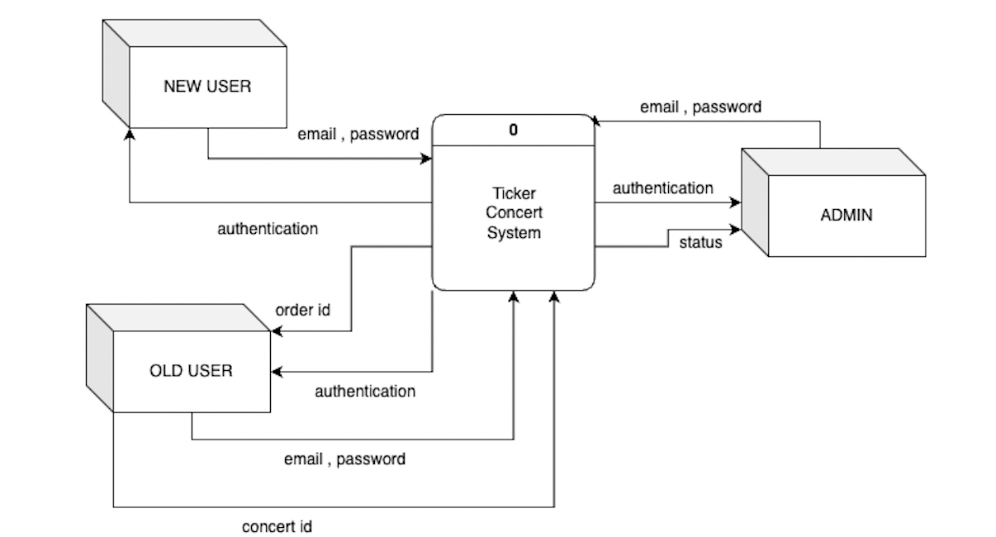

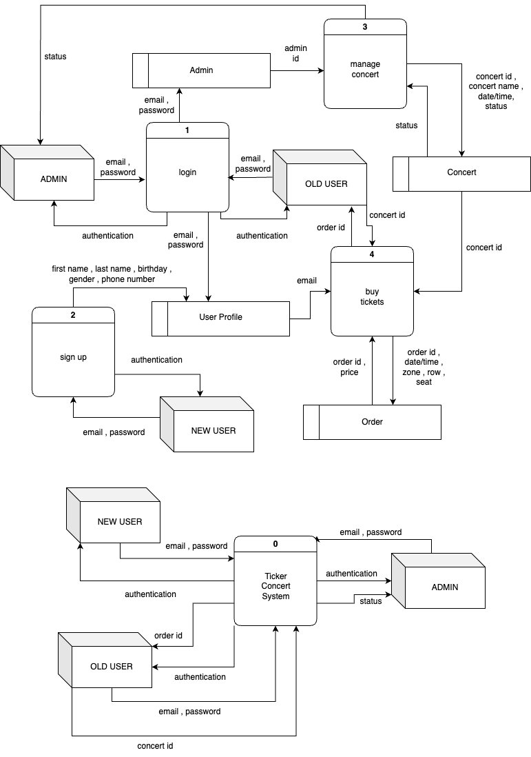DFD level 0

ER diagram

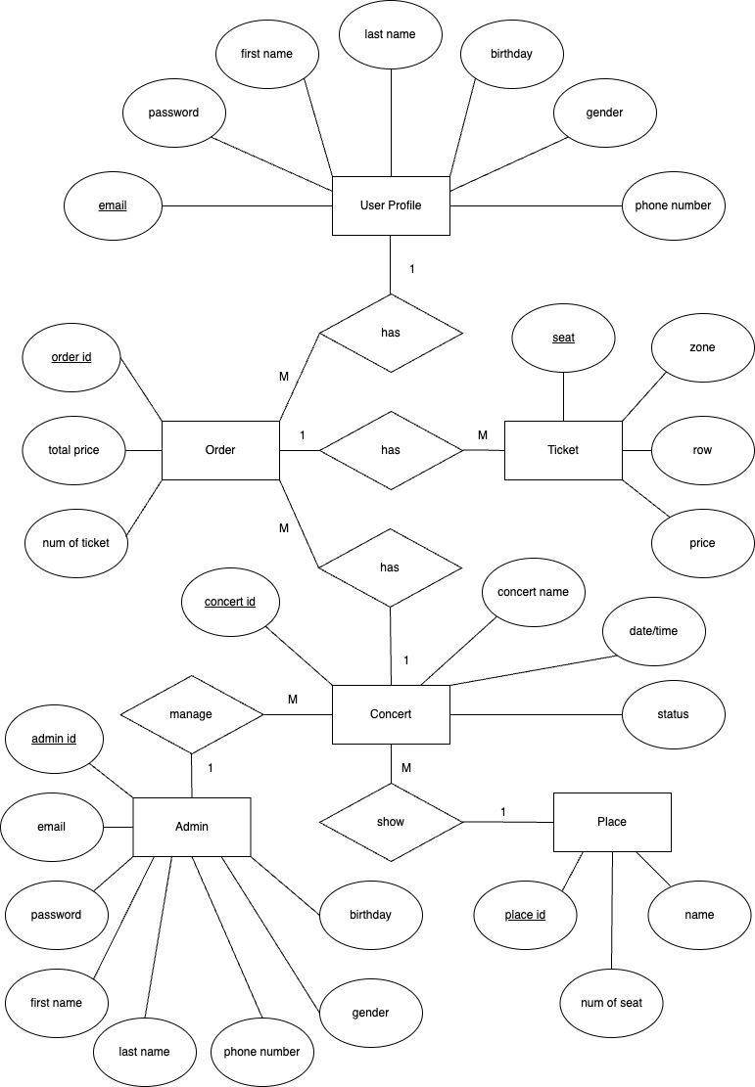

User Profile Table

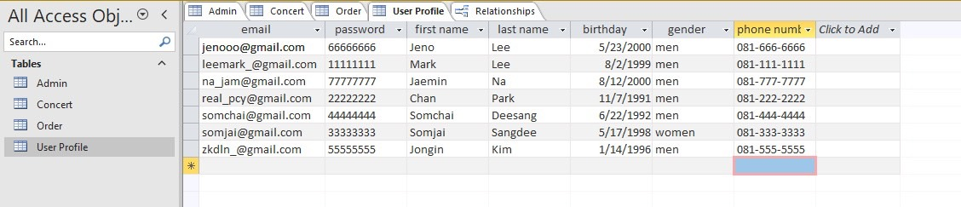

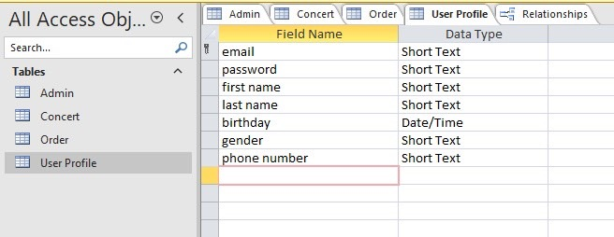

Order Table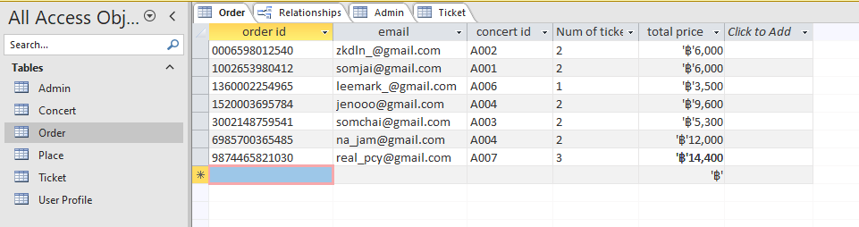

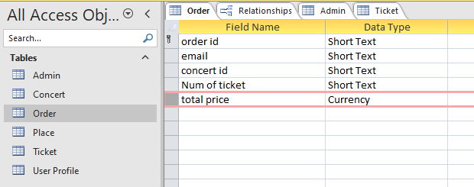

Admin Table

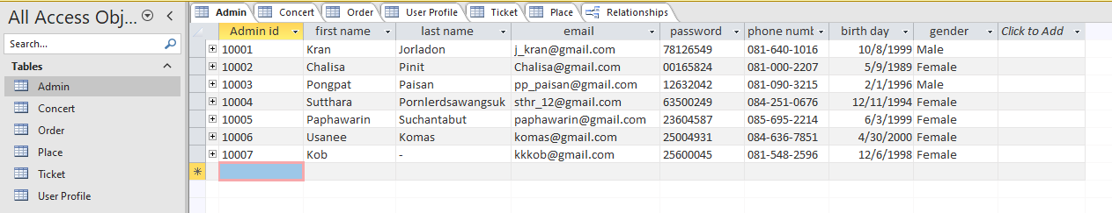

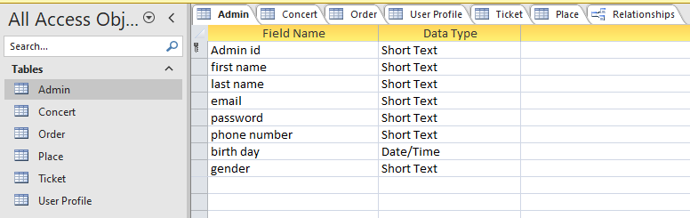

Concert Table

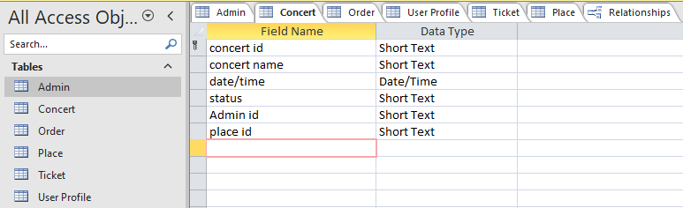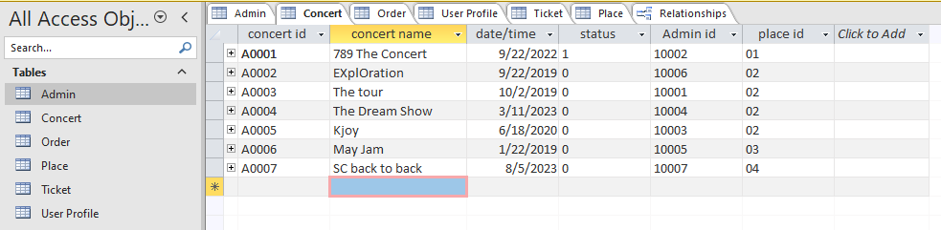

Ticket Table

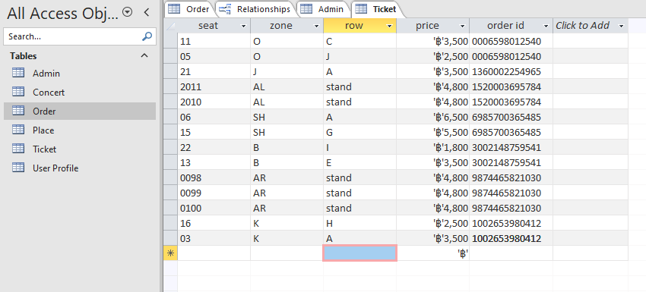

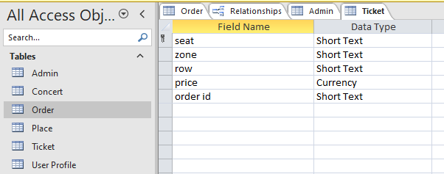

Place Table

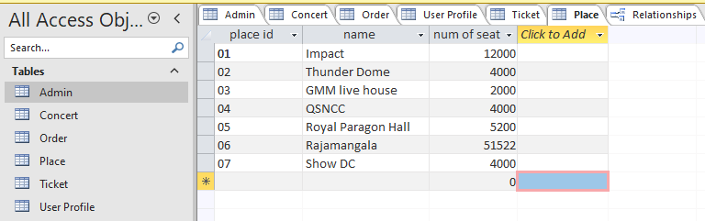

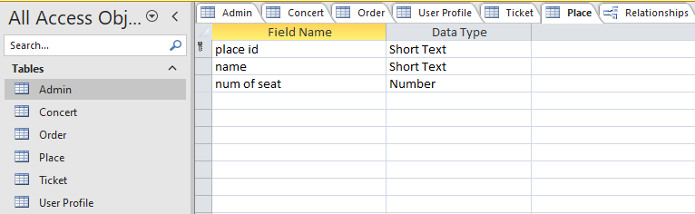

Relationships

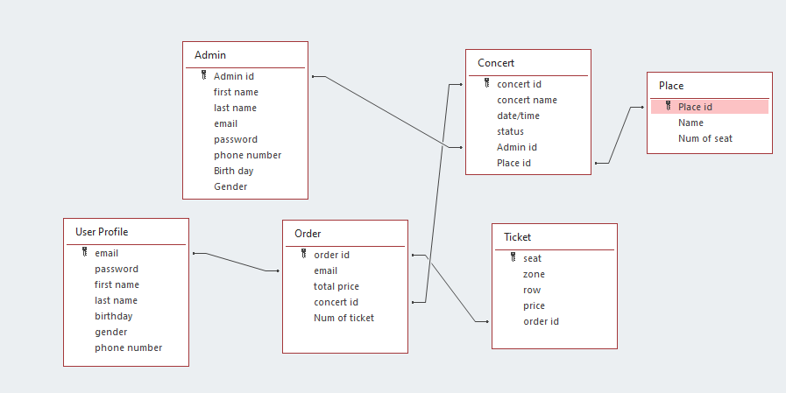

Class diagram

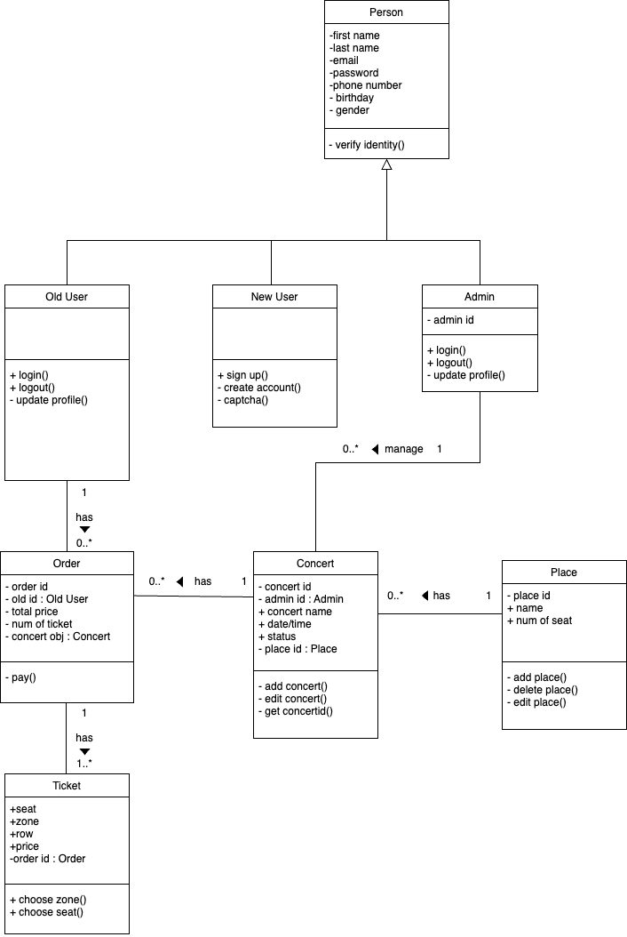

Activity diagram

Sign up

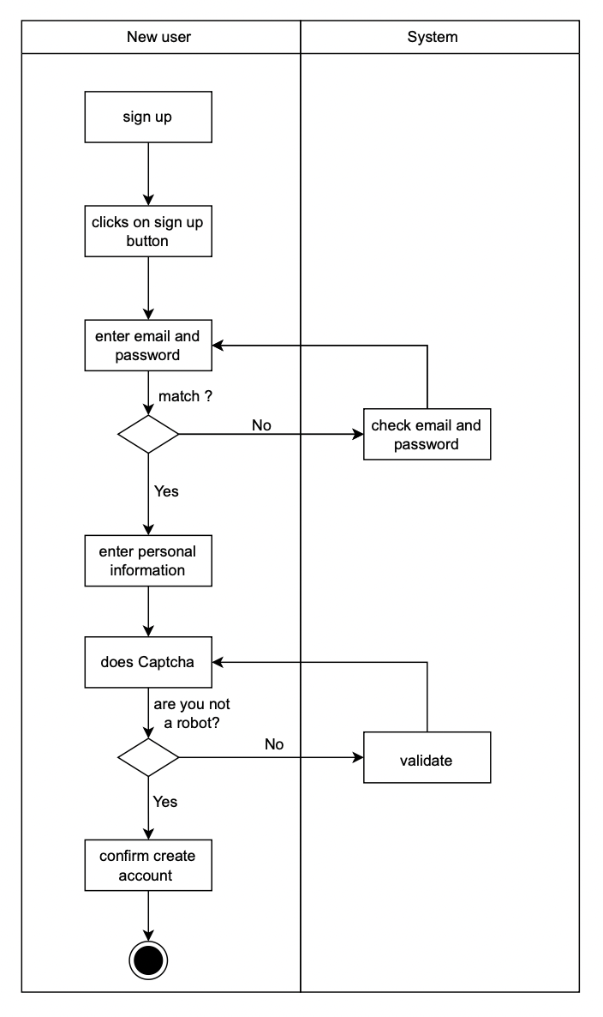

Log in

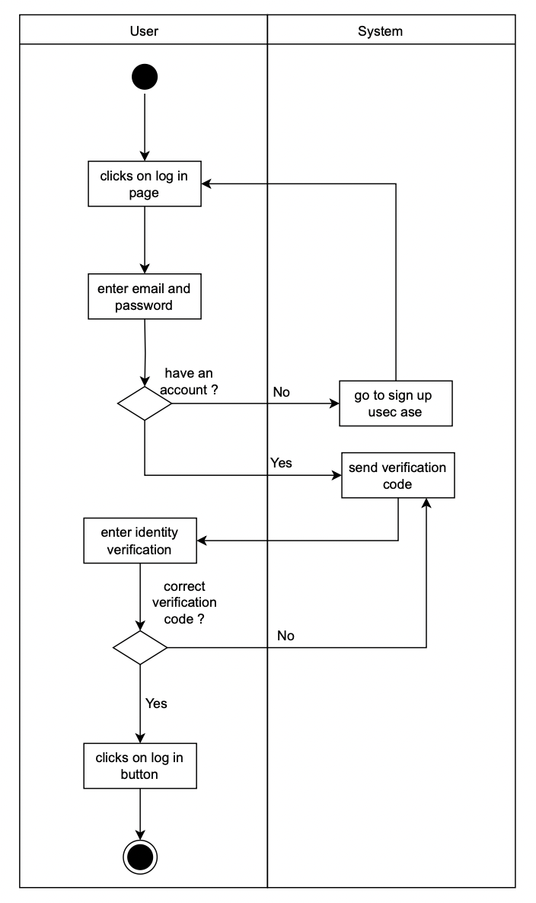

Buy ticket

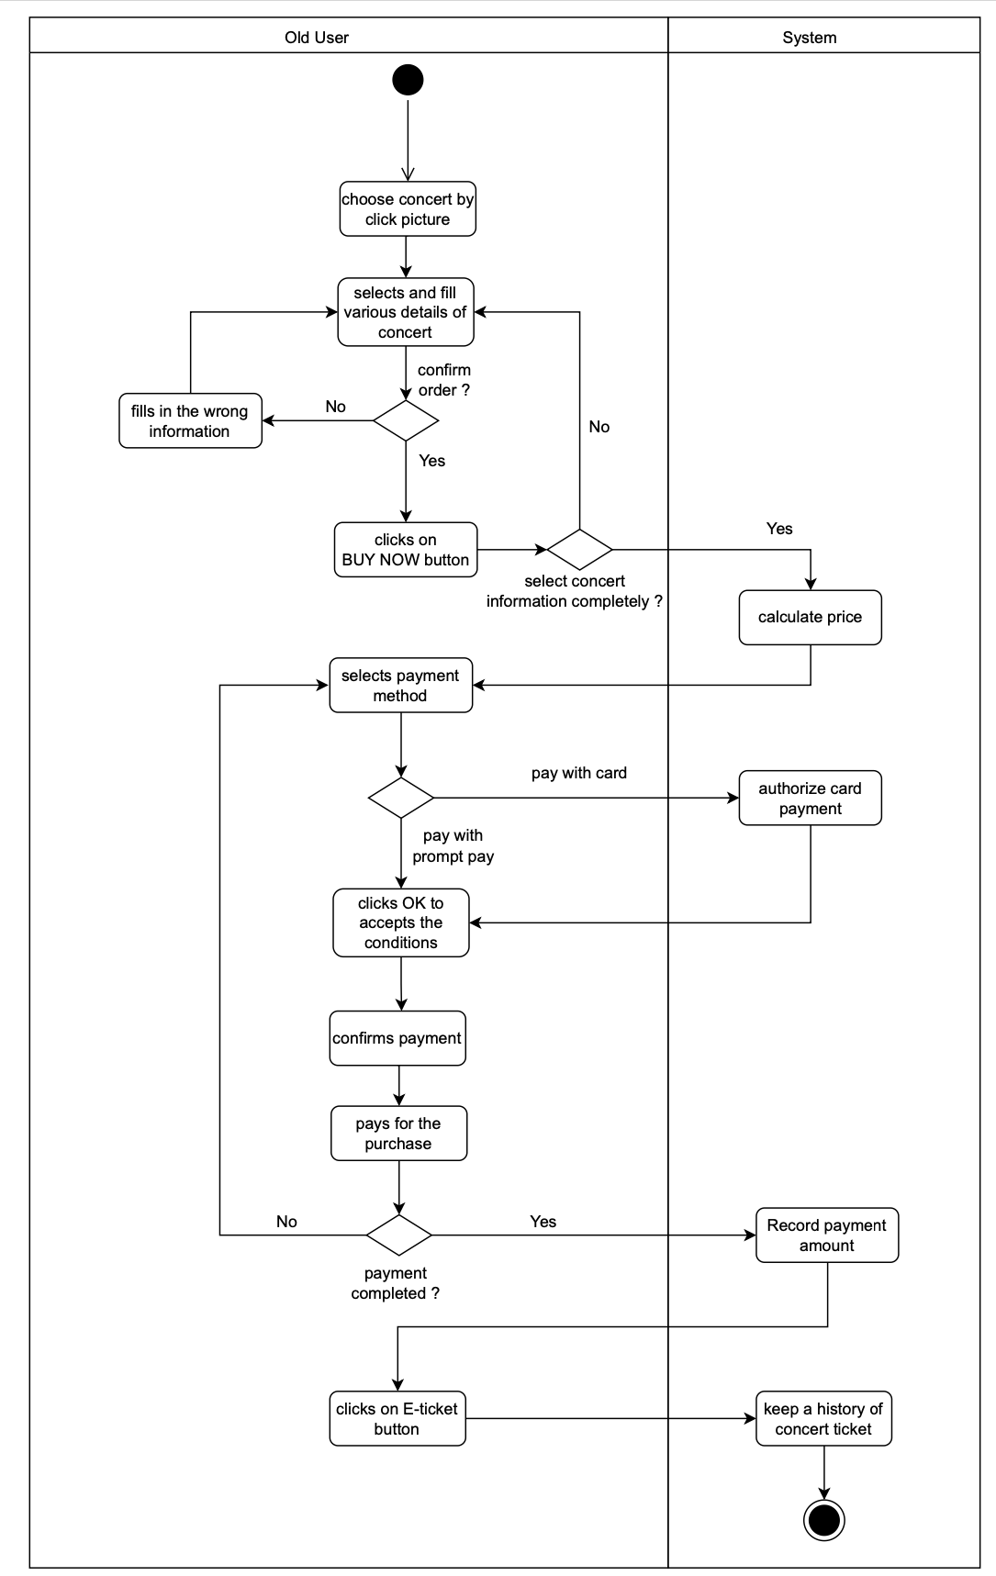

Manage concert data

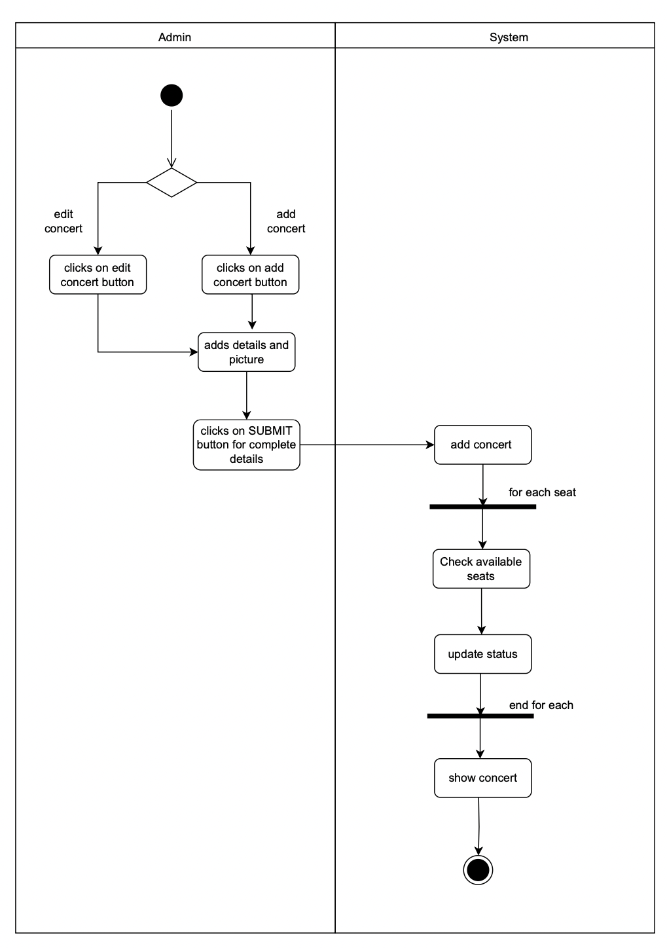

Sign up ( Sutthara Pornlerdsawangsuk Student ID 6504062620205 No.44 )

System Sequence diagram of Sign up

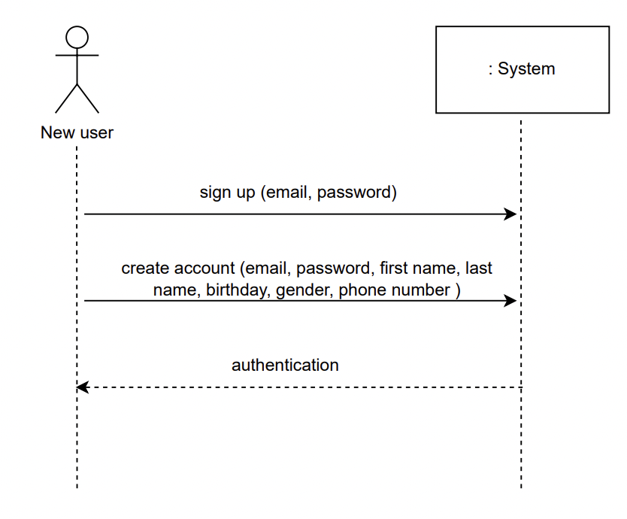

Detail Sequence diagram of Sign up

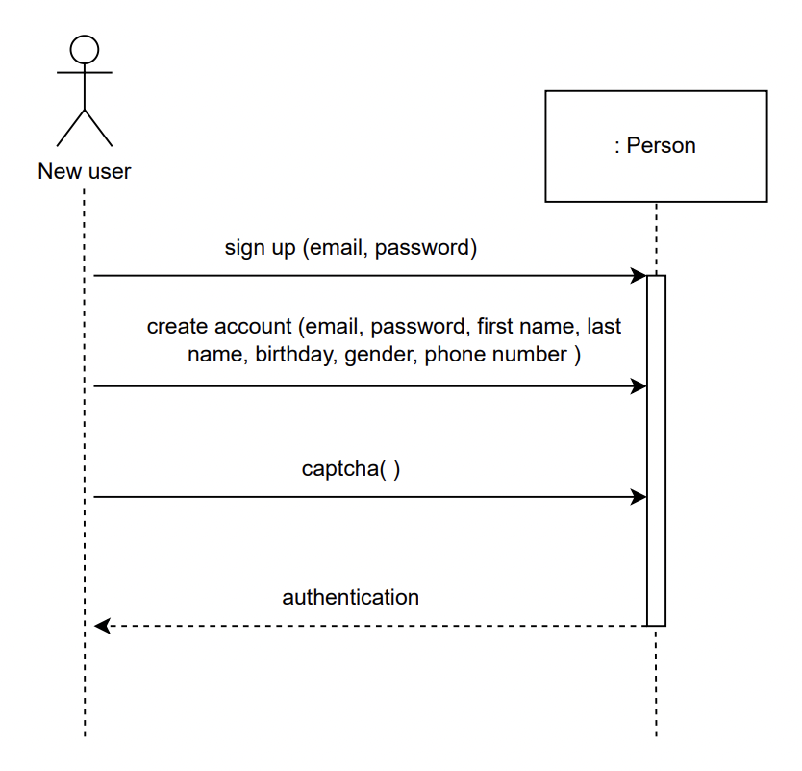

Log in (Usanee Komas Student ID 6504062610331 No.28)

System Sequence diagram of Log in

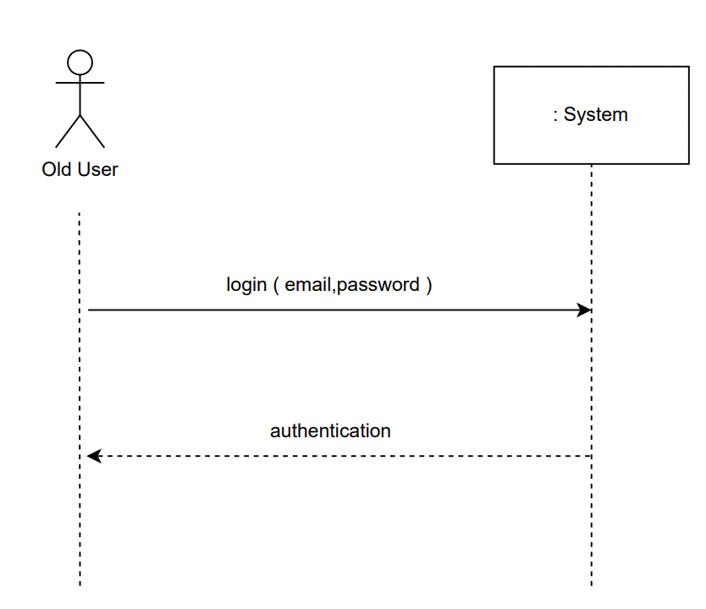

Detail Sequence diagram of Log in

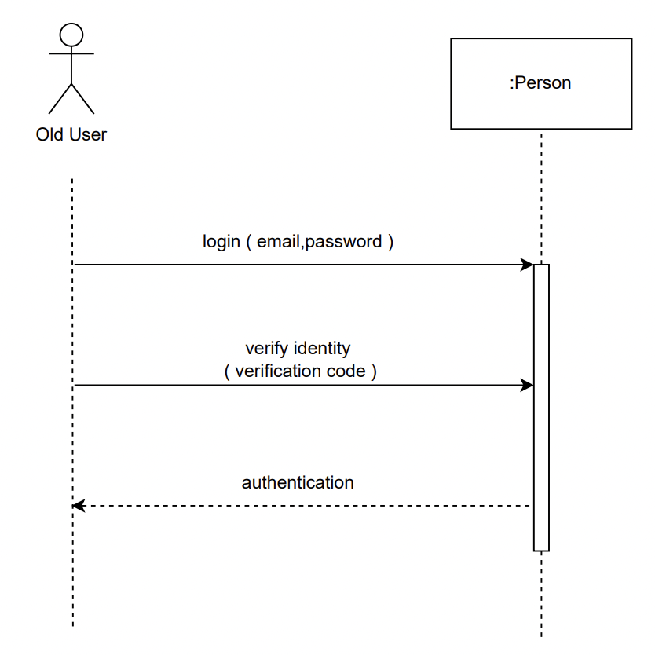

Buy ticket (Paphawarin Suchantabut Student ID 6504062610170 No.15 )

System Sequence diagram of Buy ticket

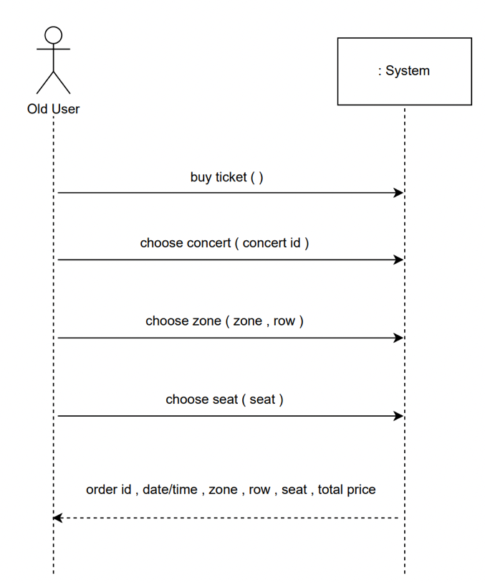

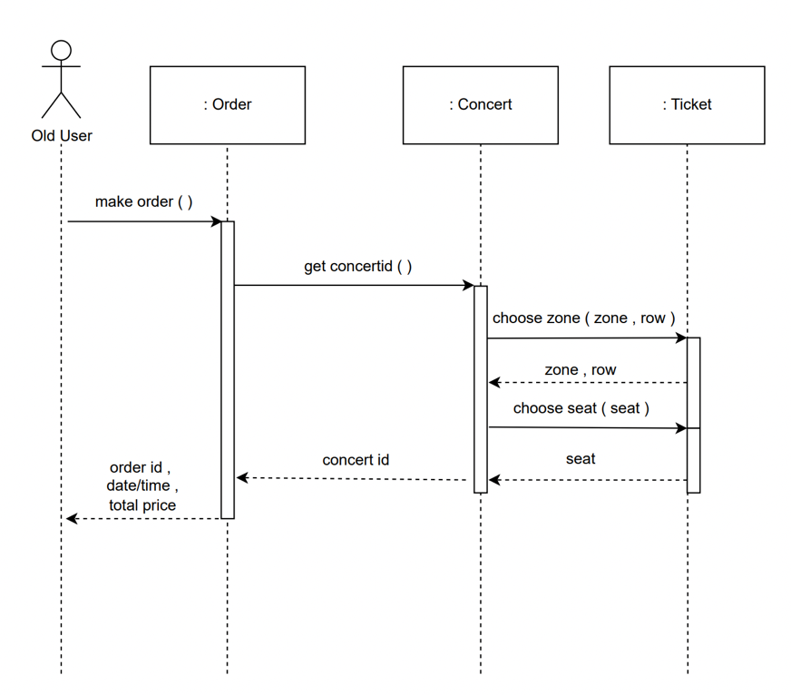Detail Sequence diagram of Buy ticket

Manage concert data ( Kob Student ID 6504062610013 No.2 )

System Sequence diagram of Add concert

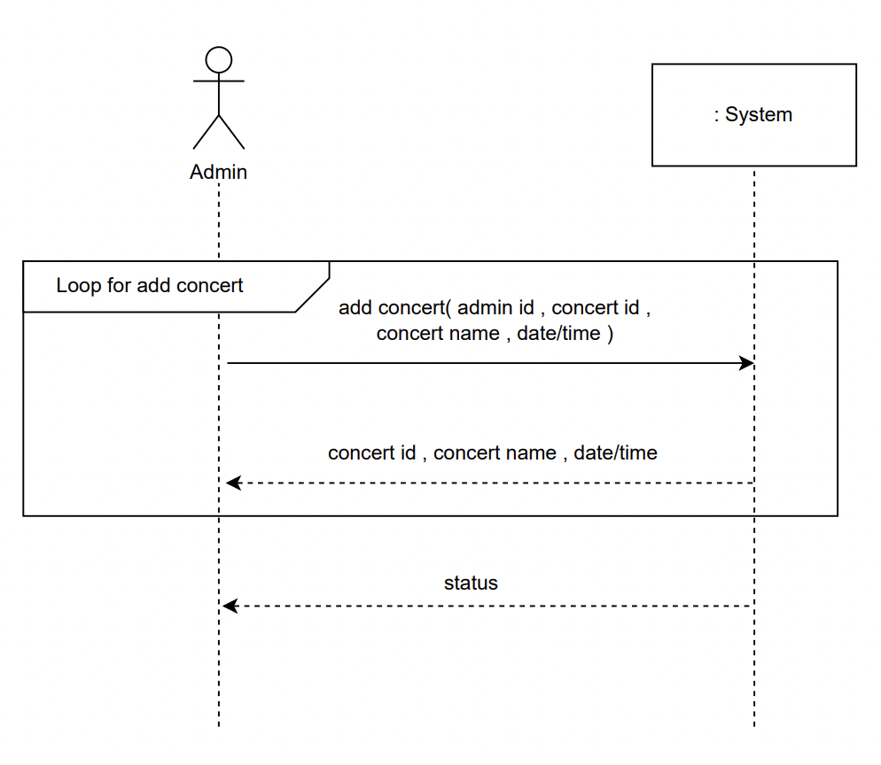

Detail Sequence diagram of Add concert

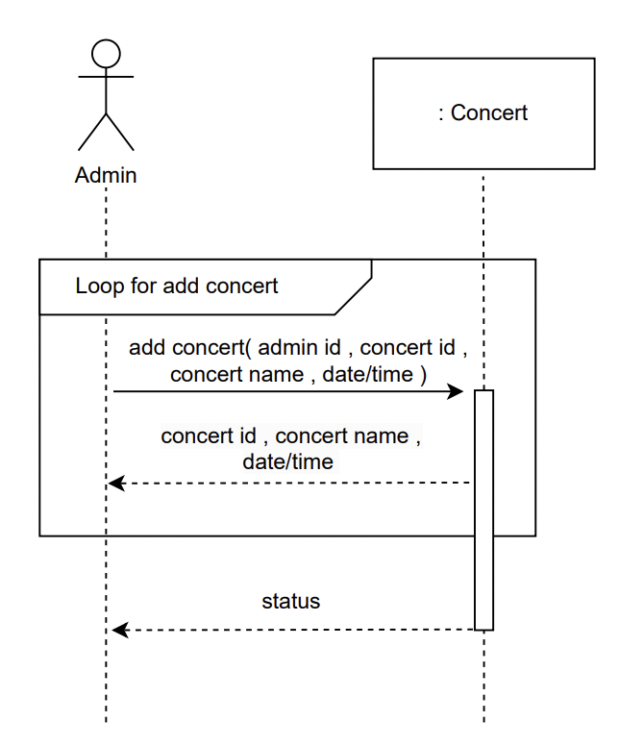

Manage concert data ( Kob Student ID 6504062610013 No.2 )

System Sequence diagram of Edit concert

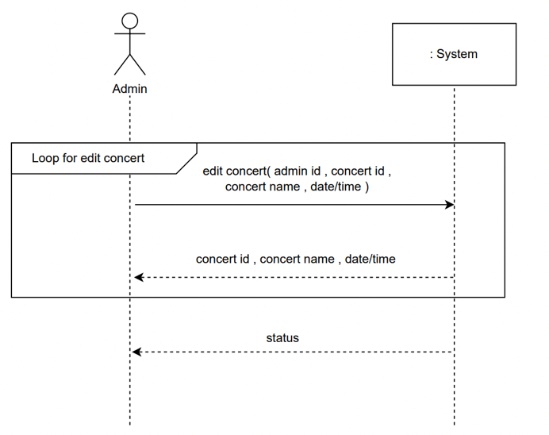

Detail Sequence diagram of Edit concert

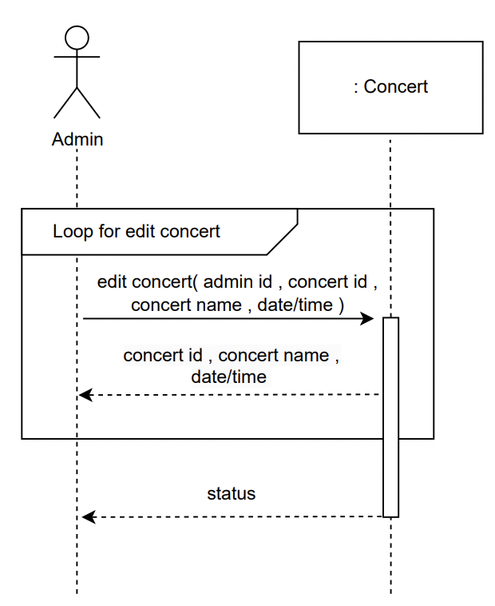

UI ( Kob Student ID 6504062610013 No.2 )

Profile

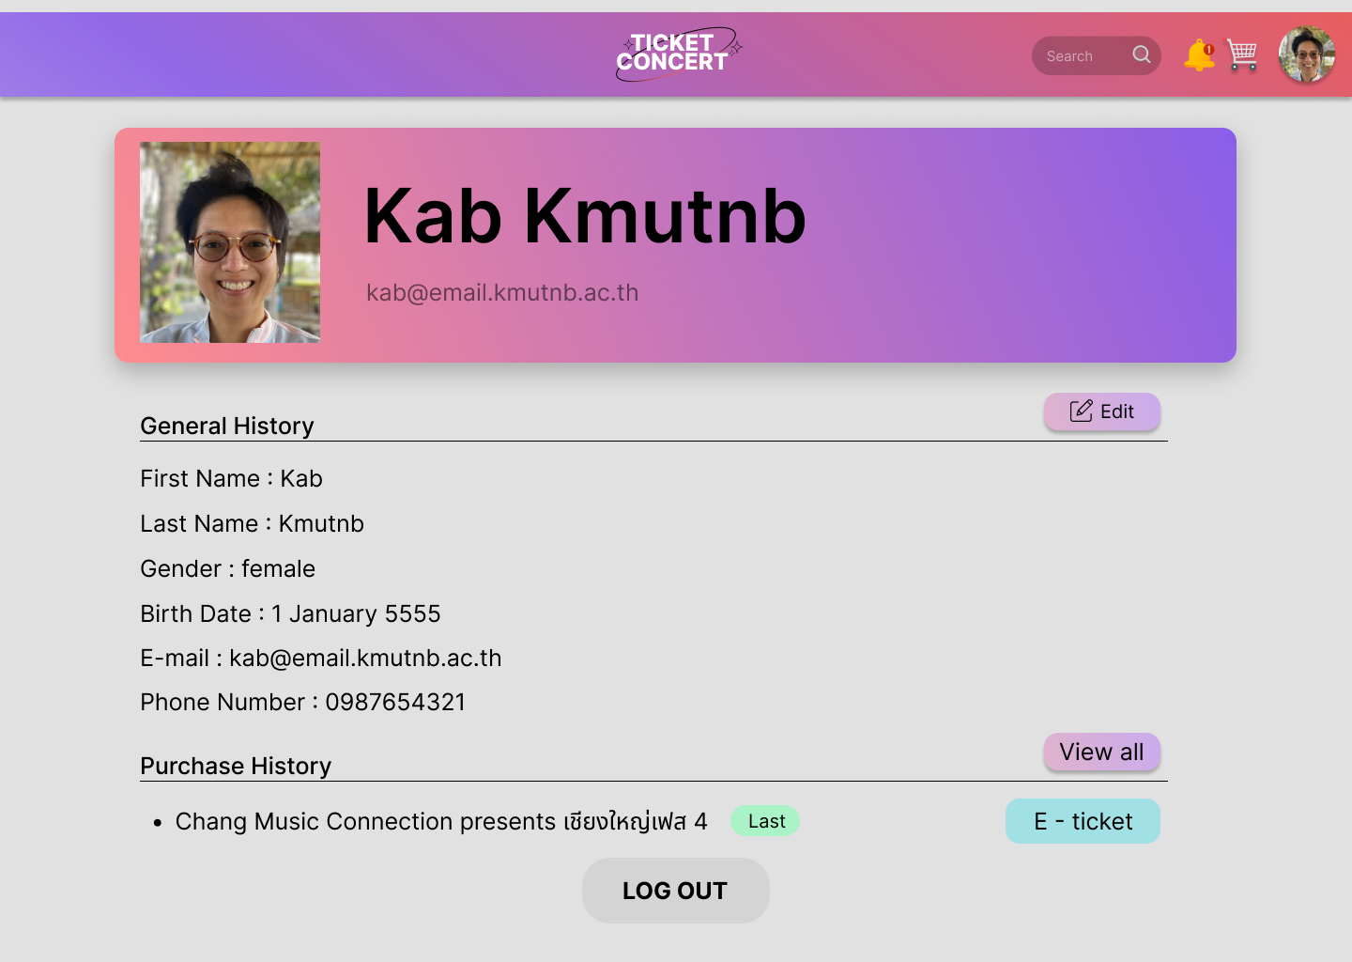

Edit Profile

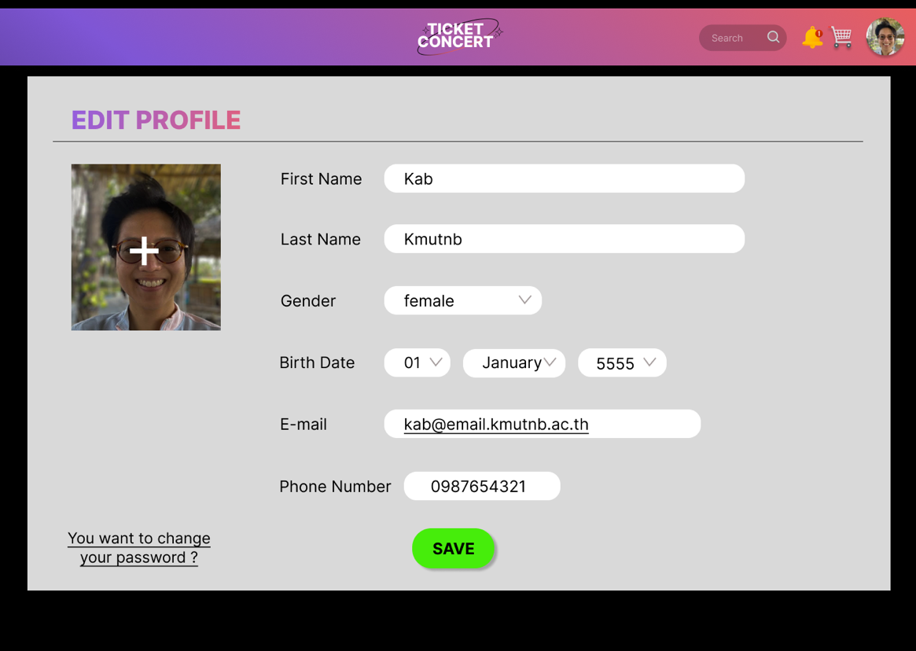

UI ( Kob Student ID 6504062610013 No.2 )

E ticket

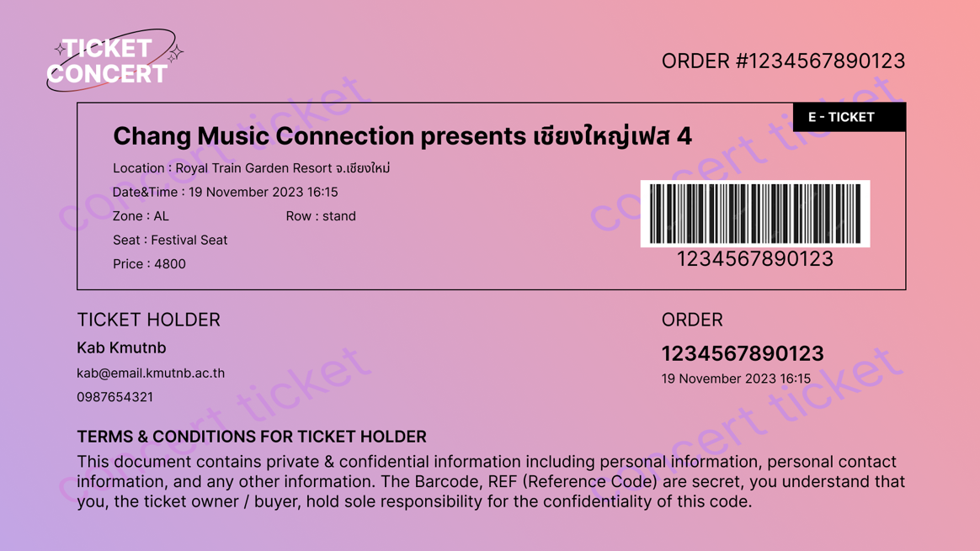

Bought tickets

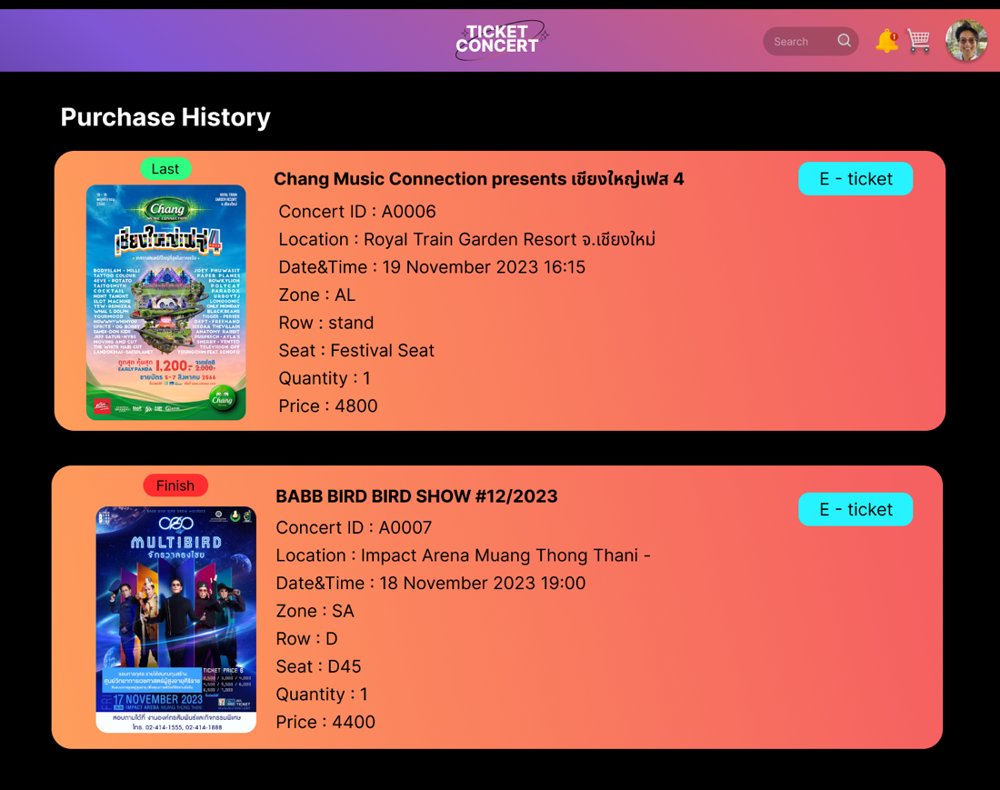

UI ( Paphawarin Suchantabut Student ID 6504062610170 No.15 )

Login

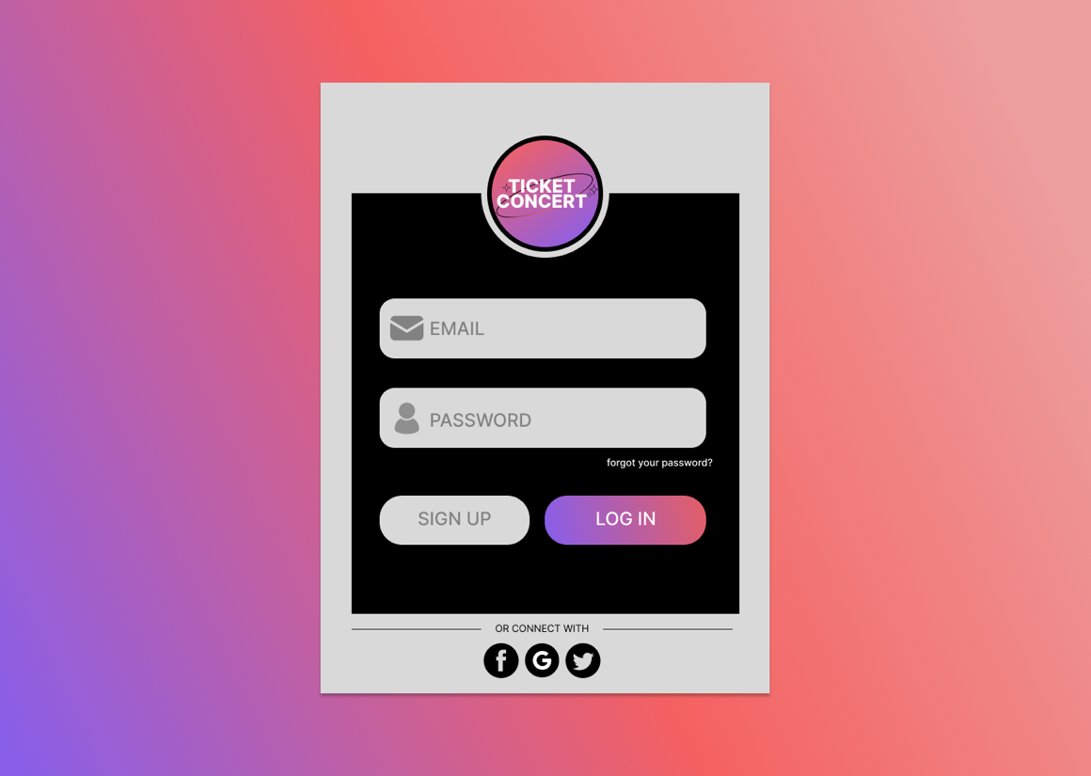

Create account

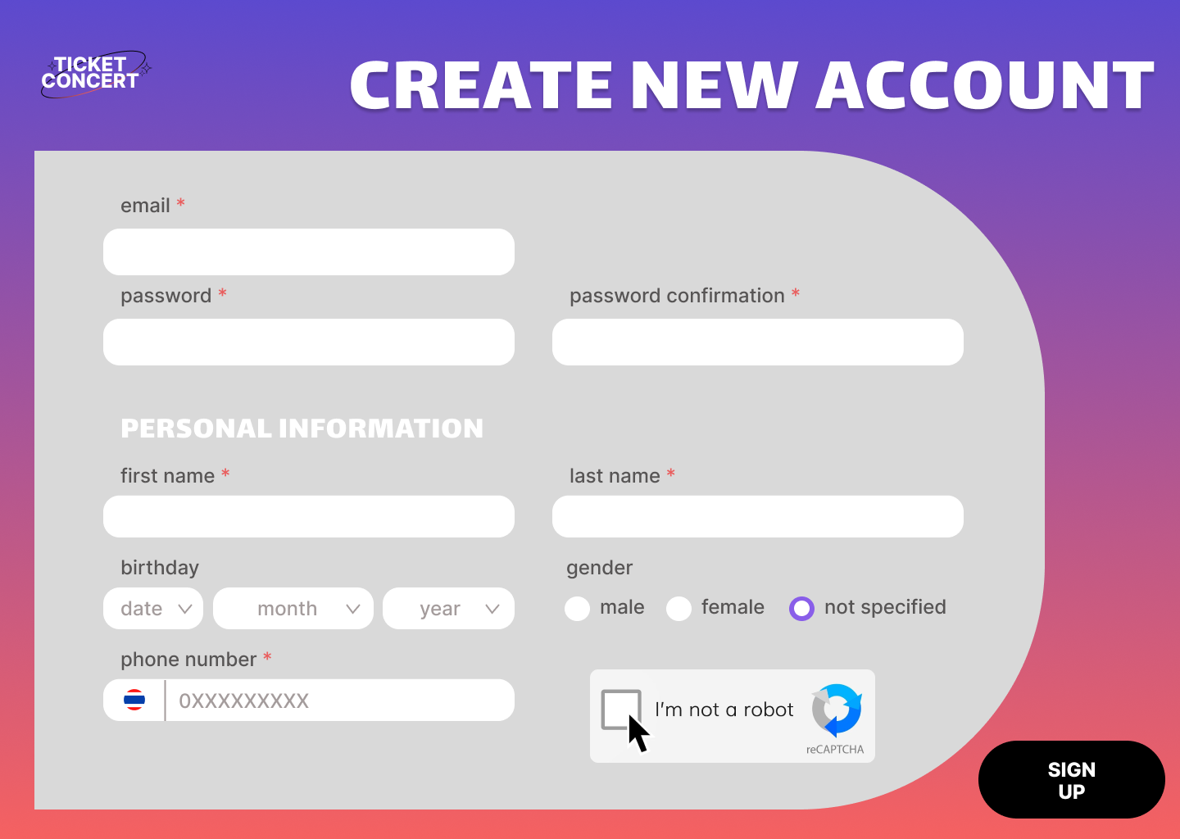

Verify

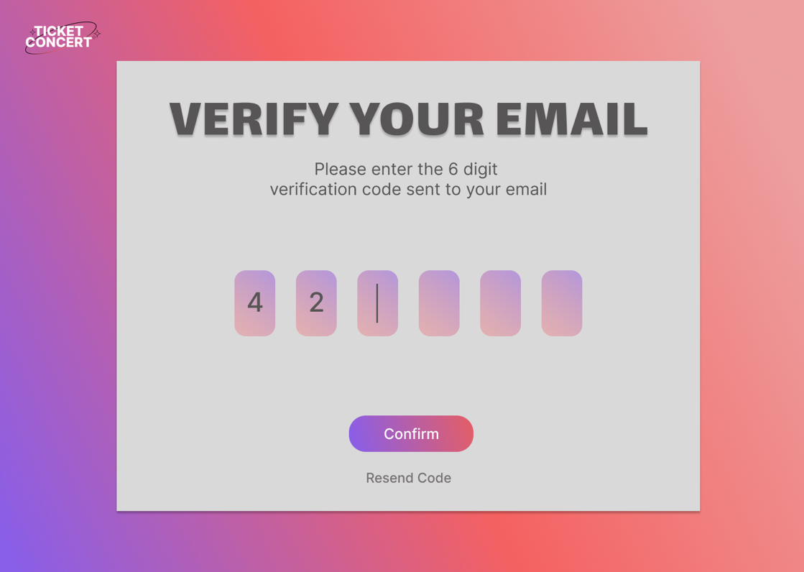

UI ( Usanee Komas Student ID 6504062610331 No.28)

Home

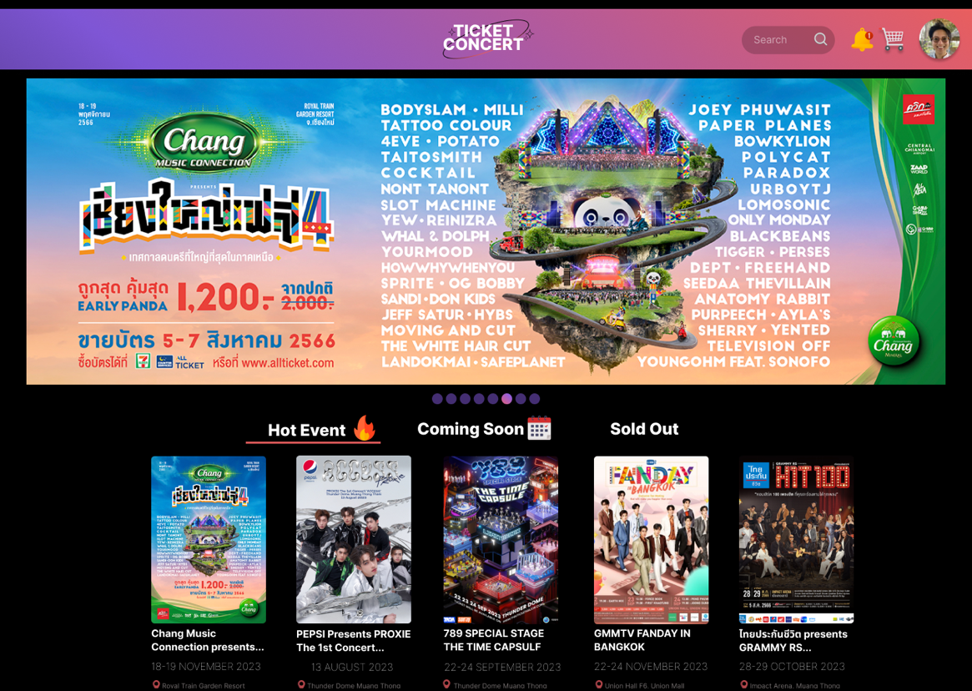

UI ( Usanee Komas Student ID 6504062610331 No.28)

Admin

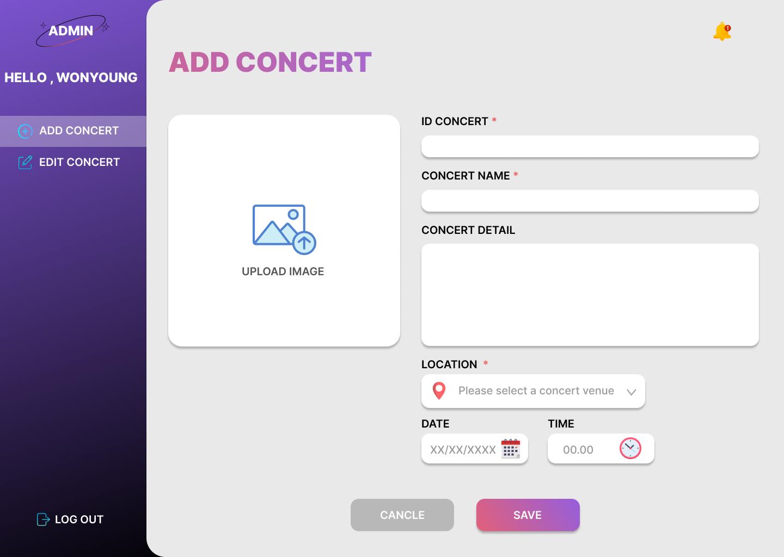

Cash

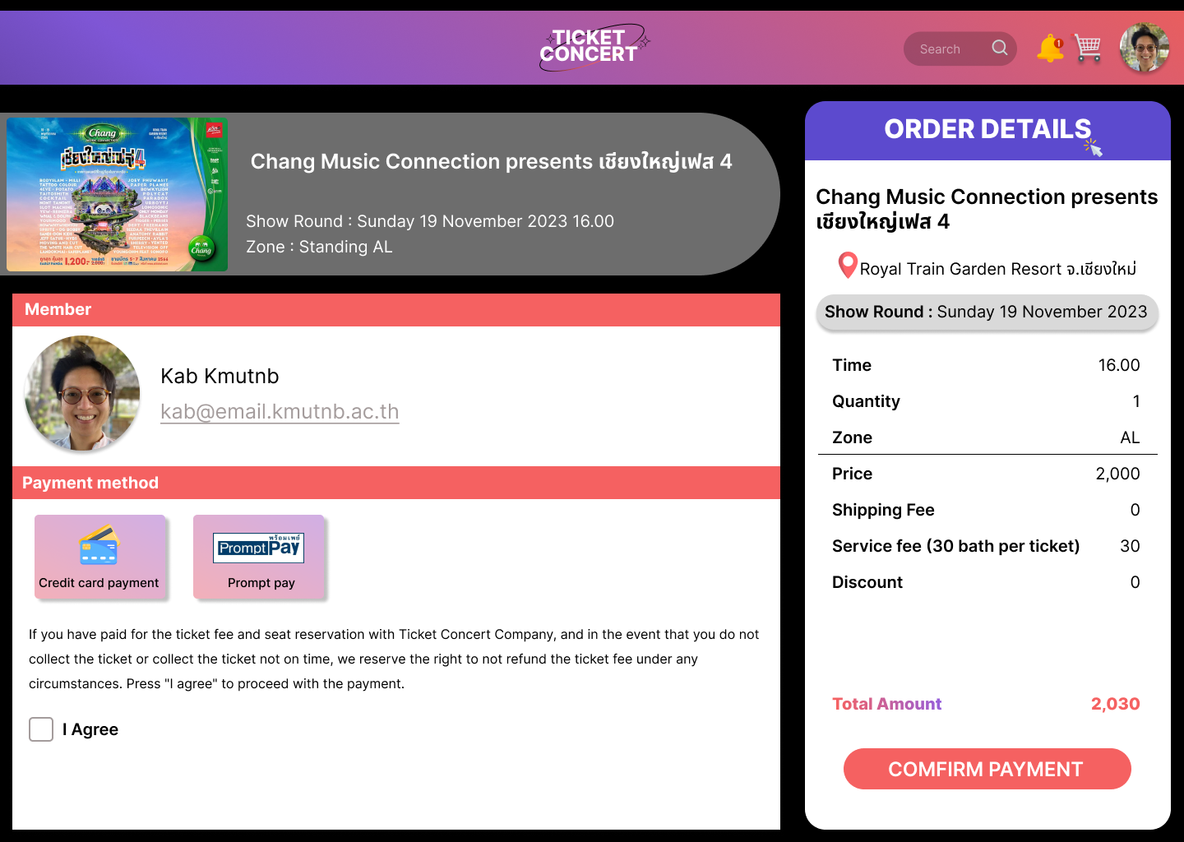

UI ( Sutthara Pornlerdsawangsuk Student ID 6504062620205 No.44 )

Zone

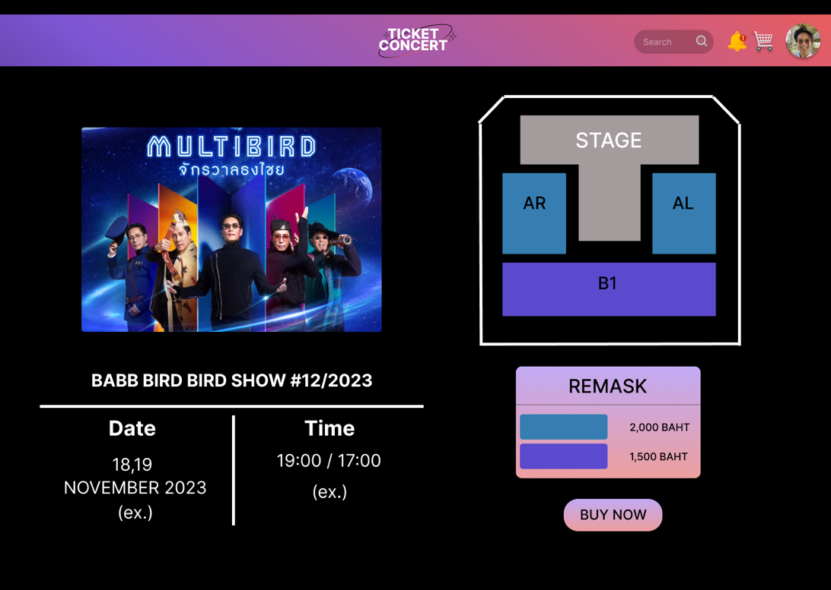

Seat

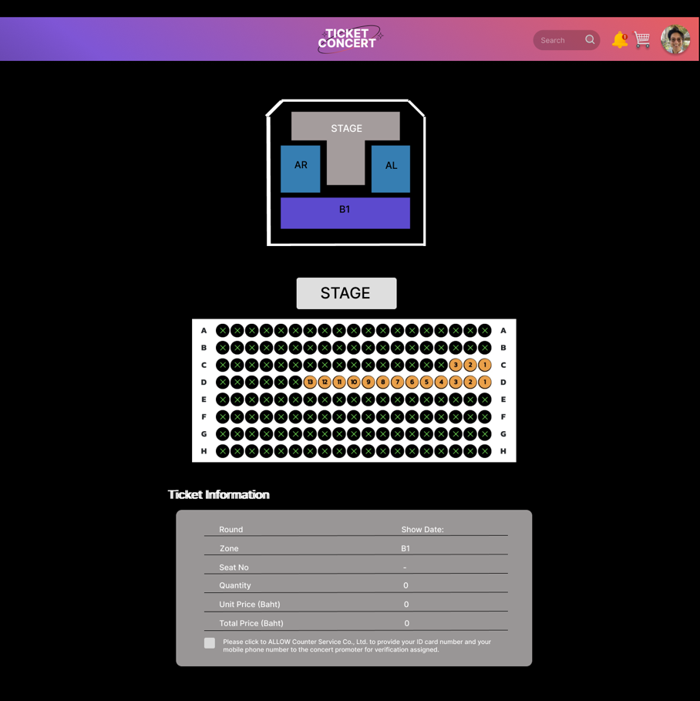

Error Handling ( Kob Student ID 6504062610013 No.2 )

* Please enter a complete 10 digit phone number. If you do not have a Thailand phone number, please contact Admin by..........
* Your email address was not found. Please enter your email again.

You must have (@).

* Are you sure to log out? If you want to log out, please Click again.

Error Handling ( Paphawarin Suchantabut Student ID 6504062610170 No.15 )

* We couldn't find your account. Please enter an email again

or click **Sign up** to create a new account.

* The password is incorrect. Please try again or click **forgot your password** to reset it.
* The verification code is incorrect. Please click **Resend Code**

to receive a new code via email.

Error Handling ( Usanee Komas Student ID 6504062610331 No.28)

* Please choose a payment method.
* Please accept the terms and conditions before continuing.
* Successfully booked tickets.

Error Handling ( Sutthara Pornlerdsawangsuk Student ID 6504062620205 No.44 )

* There are no more seats available in this zone.
* This seat is not available.
* Please select a show date.